Problem Statement
The same municipal crime incident table used in the R-syntax project must now be turned into clear, audience-adapted graphics. Command needs quick visual answers: Which crime types dominate? Where is the high-volume tail? How does severity differ by type? Which cases attract media attention while remaining unsolved? ggplot2’s grammar of graphics supplies a consistent way to answer these questions.

Solution Strategy
Follow the layered grammar:
- Data + aesthetics (aes) map variables to x, y, fill, color, size.
- Geoms (bar, histogram, boxplot, point, col) choose the visual mark.
- Annotations (vline for the 15 k threshold, smooth trend) add decision context.
- Themes + labs keep titles short and executive-friendly; simulation cells let the threshold change live.

Solution
Six core plots were produced (bar counts, histogram + threshold, severity boxplots, scatter with trend, priority split, mean monthly by type). Assault dominates frequency; Homicide/Drug Offense lead severity; the 15 000-incident line cleanly flags the high-priority tail; media volume rises with incidents and many high-volume points remain unsolved.
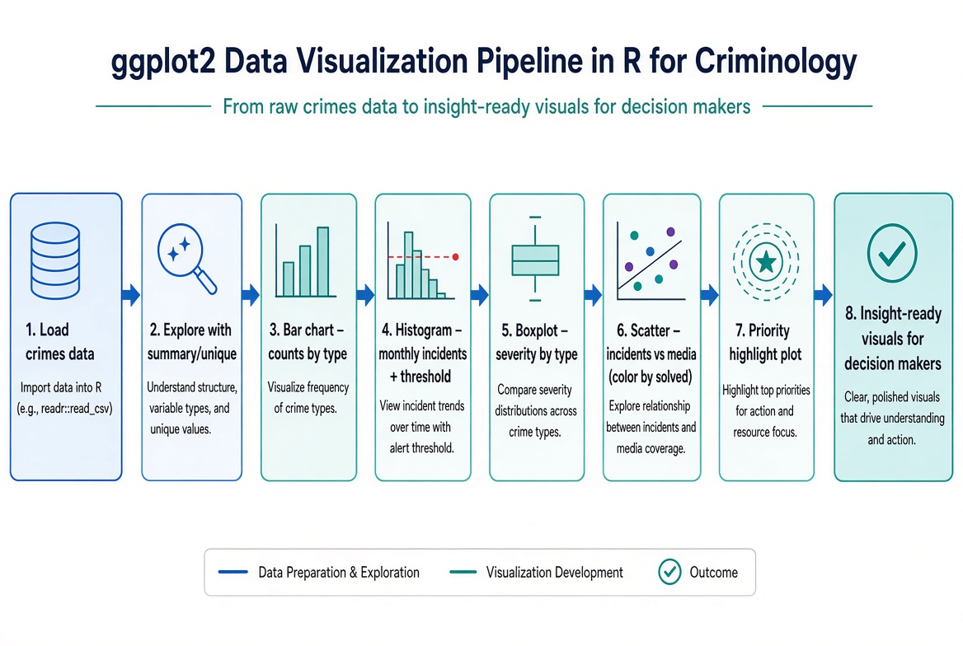
Figure 1. ggplot2 visualization pipeline.
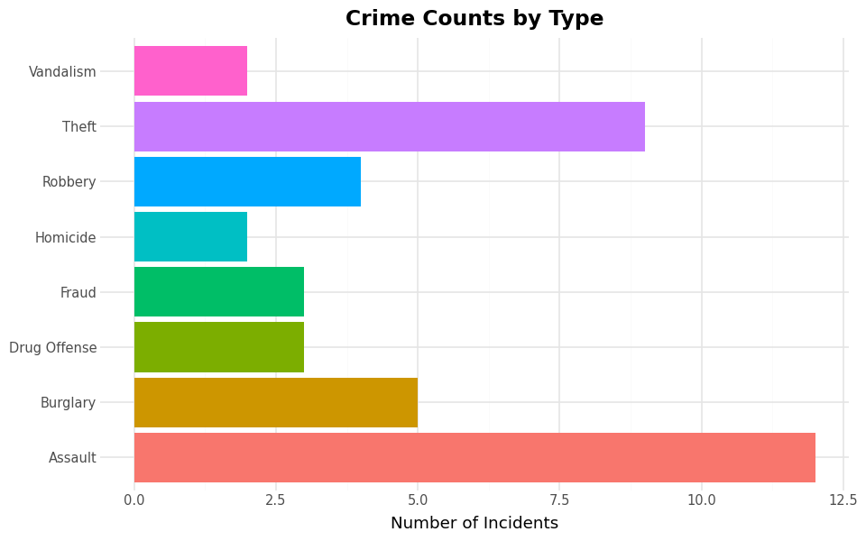
Crime counts by type (Assault leads).
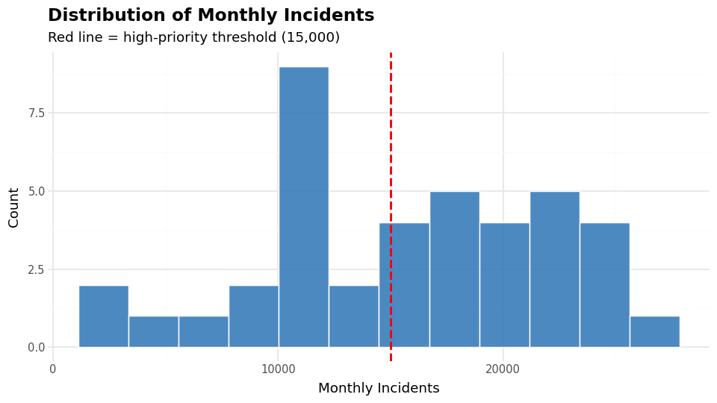
Monthly-incident distribution with 15 k decision threshold.

Key Takeaways
- ggplot2 maps data → aesthetics → geoms → annotations in a consistent grammar that scales from quick EDA to polished briefings.
- A single threshold line on a histogram turns a distribution into an actionable priority rule for executives.
- Boxplots and reordered bars answer “which types matter most for severity vs volume” at a glance.
- Simulation (changing the threshold) lets analysts and commanders explore resource implications visually.

